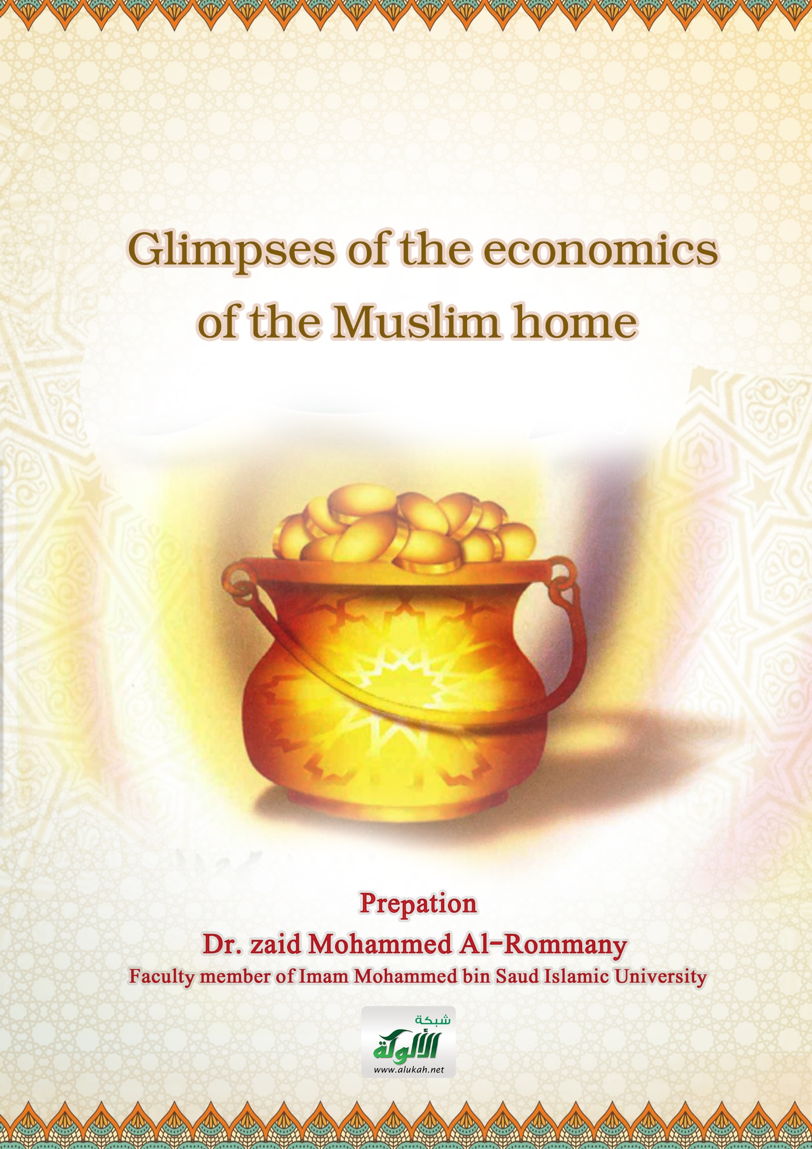
Reading For All 215

Glimpses of the economics of the Muslim home

Prepation
Dr. zaid Mohammed Al-Rommany
Faculty member of Imam Mohammed bin Saud Islamic University
2021

All praised be to Allah , prayer and peace on his slave Mustafa, and after.
Dear Reader brother: Here are brief glimpses of the economics of the Muslim house, talking about the importance of the family budget and the need to plan beginning and end, dealing with important consumer issues and presenting some of the necessary controls when making a purchase decision.
Yes, they are short glimpses, but they are necessary for every head of family and housewife.
I hope that it will benefit everyone and benefit from it, the young and the old, and that, God willing, they will be good girls in the Muslim house.
I ask Allah to help us for all good
Author

Family budget
The housewife plays an important role in delighting her family by wisely managing the affairs of the house and managing his expenses and the health of his members, the house is the place where all the family members are happy.
One of the factors helping to provide happiness in the family in the material terms in terms of estimating the income of the family and regulating its budgets so that it provides all the needs and requirements of the family to maintain the health of individuals and secure clothing and comfortable housing.
The housewife should therefore monitor the family budget through various spending doors at the end of each week or every month so that she can judge what has been spent within the limits of the decision so that she can avoid overspending on purchases.
If the family is interested in allocating funds to save and save for the time of need and various emergencies.
The material potential of the family should also be taken into account by following the proper system of expenditure in terms of not increasing the amount spent on income, but should be lower than it should be in order to save money from it in time of need
Therefore, all family members should discover the wasteful places of spending and learn to avoid them.
Through this glance, I call for a tight budget for the family that controls expenditures, limits revenues and determines the aspects of disbursement, because of the great benefits to family members, society as a whole and the State for the benefit and good.

Consumer models
The conscious housewife should be the first to maintain the family budget and try to save on expenses and expenses, because Allah does not like the extravagant and "not extravagant" and said "he did not waste", said "do not waste" and said "do not waste" and "do not waste" because Allah does not like the extravagant and the wasteful brothers of demons.
The rational consumer is that consumer who takes into account the principle of rationality, rationality and moderation in his food, drink, clothing, house, car and furniture, and his use of water and electricity to protect himself and his family.
Scientific progress has led to an increase in modern equipment and tools used in homes and these modern devices and tools if used incorrectly lead to damage and dangers to the safety of the family such as cleaning tools, electrical appliances and cooking utensils.
In fact that prevention is better than treatment.
Therefore, all family members should be interested in following the correct safety rules and instructions on the devices of all kinds to provide safety and safety at home.
Through this glance, I call on all family members to set an example in their consumption, use and behaviour by taking into account the economy of expenditures, moderation in expenses, rationalization of use and reduction of images of waste and destruction.

Folly buying clothes
Whatever the family spends a large or small part of its income on clothing, it requires planning , knowledge of clothing and purchasing practices; clothing sellers may be more accustomed to selling their goods through advertising, offers and resonant names than on the important foundations of awareness.
Therefore ,The buyer should be accustomed to quality standards and levels to become more interested in the real content of the goods as the trademarks of fixed quality are often good, but the buyer may pay a heavy price for the well-known name and resonance of the brand.
Consumer protection should therefore begin to buy clothing for consumers themselves by developing their attitudes towards knowledge of purchases and the desire for the best quality with the lowest amount of money.
The first step to better develop purchasing habits is to use detailed guidance such as a purchase plan that depends on identifying the necessary needs, estimating the cost of each need and comparing costs with the budget set for purchase.
Here, be careful not to avoid emotional purchase, by making a plan for the things required before doing the shopping process.
The most dangerous thing that passes on the family is the so-called folly buying, shopping and responding to the consumption of appearance reviews and exaggeration in fashion and fashion and the context behind advertising and deceptive advertising without careful arbitration of the mind and appreciation of the consequences and consequences.

Home furnishing and elegance
The process of furnishing the house is an important thing facing the family due to the huge amounts it needs, but with some study and wisdom, the successful housewife can make her home a model of elegance without fatigue for the family budget, so the housewife has to save to buy furniture and choose what the family needs and benefit from it so that the house does not crowd the different varieties and becomes as if it is exposed to antiques and furnishings.
The house is where people live after a whole day's effort, the father goes to work , the children to studies and the mother may goes to work as well.
Providing the necessary conditions in the rooms of the house makes the family members appreciate and feel the beauty and grow with them the love of beauty and taste.
Therefore, the housewife must have the right atmosphere and the right place for her family members, this is one of the greatest reasons for their happiness, and the housewife must take into account simplicity and not cost in the taste of furnishing the house and choosing furniture, this reflects her maturity and awareness.
Beware of the attraction behind the huge prices, high prices, misleading propaganda, false advertisements and huge decorations, the important thing is elegance, quality, mastery and beauty without waste.
These are some of the awareness signals that we loved in this glimpse to remind our brothers, mothers, daughters and women for the sake of a social family economic awareness that achieves well-being and bliss without cost or trouble.

Consumption limits
Islam's principled position on consumption is governed by fundamental values, the content of which is the legalization of consumption and the legalization of achieving the best possible levels, we affirm this from the beginning so that no one imagines that Islam is insulting consumption or standing in the way of increasing it.
The meaning of consumpion has been followed in the good of many individuals by incorrect concepts that consumption is a negative process and behaviour that exhausts the economies of countries, and this concept has been deepened by the propaganda broadcast by the media in the ears of people urging production and warning against consumption because production gives, benefits and consumption is wasted and not useful.
If the descriptions that have been attached to the production are incorrect, what has been attached to consumption is not true, because consumption is not pure evil, not waste or destruction of goods or services, but it is good and constructive for the body, mind and abilities.
The principled position of Islam on rational consumption is to allow it and call for it and to bring it within the limits of what enables the individual to carry out the duties and costs necessary and make it above these limits and within certain limits permissible to improve moderation and respect for legitimate values.
Through this glance, I call on my brothers and sisters to be role models in their consumption and to have their consumption rational and just research, not waste, insolence or disreliging.

Individual consumption pattern
Rationalizing consumption is one of the most important objectives of societies in general , countries are working to rationalize and regulate consumption for citizens , whether individual or household.
The pattern of consumption of the individual depends on the extent to which he is aware of the objectives of the State and its economic policy, as well as on the quality of information, customs and trends that have been associated with the individual from a young age with daily practices.
There is no doubt that the social normalization of the child has an impact on determining the patterns of his behavior and therefore the interest in monitoring the child and directing his behavior proper guidance is necessary so that he can participate with a share of the effort and work in regulating consumption.
Society also seeks to achieve its national goals by developing the qualities required in the citizen and its means in this: socialization, education earns the child facts, values, skills and trends, including the trend towards rationalization of consumption.
Since much of the information and data relating to the rationalization of consumption and the consumer in the first place and the formation of sound trends among the consumer are not innate but acquired, they must be studied, practiced and properly linked to aspects and requirements of daily life.
Through this glance, I stress the importance of identifying the factors affecting the consumer behavior of the child, especially the family in general, in order to reach the most appropriate means, the nearest method and the appropriate way to achieve the rationalization of real consumption.

Consumption patterns
Economists classified consumption patterns according to the main items to be divided into subdivisions, for example food consumption includes a list of the most important items of food such as bread, meat, rice and beverages of all kinds, and there are official statistics that follow this same classification.

The International Classification of Consumption includes ten elements:
1- Food 2 - Beverages 3 - Raw materials 4 - mineral fuel 5 – oils 6 - chemicals
7 - goods made 8 - machinery and transport equipment
9 - various manufactures 10 - unclassified transactions

Economists in the field of consumption agree that a family or living unit constitutes a single consumer cell with its own source of income, to which one or several individuals may contribute and that all consumers are members of a single consumer cell.
Here there is a problem in classifying patterns of consumption such as the consumption of a child, whose consumption cannot be separated from the consumption of the family, in addition to the material aspects only, children consume moral things including images, symbols and signs that drive feelings and desires.
Through this glance, I warn of the need to study the patterns of family consumption carefully and rationally,
Controls when buying
Buying is not as easy as some think, it needs thinking and know-how.
Decisions such as: How much money has the family prepared to buy and what kind of food is bought and from which places to buy needs? how to store these foods to avoid food losses.?
These decisions affect family members, so it is necessary to think and compare prices and types so that the decision to buy is appropriate.
When you intend to buy, you must not buy more than the need to buy the necessary quantities only so that the surplus is not damaged and the purchase is destroyed from clean shops that follow the correct instructions in packaging and storage.
Technical, social and economic progress has led to the emergence of central markets that have made it easier for the buyer to buy what he needs with the qualities he needs and suit his income.
Through this glance, I confirm that the decision to buy in a timely manner and for the required need in the right place, the right price and the required quality and the appropriate extent.
Why?
Because the consumer achieves wise economic guidance and rationality from the point of view of the contemporary economy, it does not fall prey to manipulation and exploitation, it is not driven by extravagance and waste, and its goods are not damaged and corrupted.

Planning beginning and end
Planning is the first step in the administrative process, the plan is a vision of future work and is a stage that precedes any work.
In the family, all its members must participate in the management of their affairs to the extent permitted by their age and abilities.
The planning phase is one of the most important stages in which all family members should be involved and meet to discuss their problems and their desires and trade-off between the objectives put forward in the light of the available resources.
This is done through a group discussion of everyone who says their opinion, presents their proposals and plans are made accordingly.
Such a discussion strengthens family ties and helps to form individuals' personalities and sense of responsibility.
There is a lot of work that the individual needs to do at a specific time he needs work that has never been done before, in which case planning is the right solution.
Planning determines the steps to be taken to reach a specific goal, while specifying the time required to complete these steps.
Through planning, the obstacles that we may encounter and the result we reach can be imagined.

In conclusion, my dear reader brother, I say that the work and duties are many and the times are few, so plan each work and make a specific plan and important priorities and focus on certain goals and then you have to do the work well and organized and let success be your ally.

May God's peace and blessings be upin our prophet Mohammed ,his family and companions

