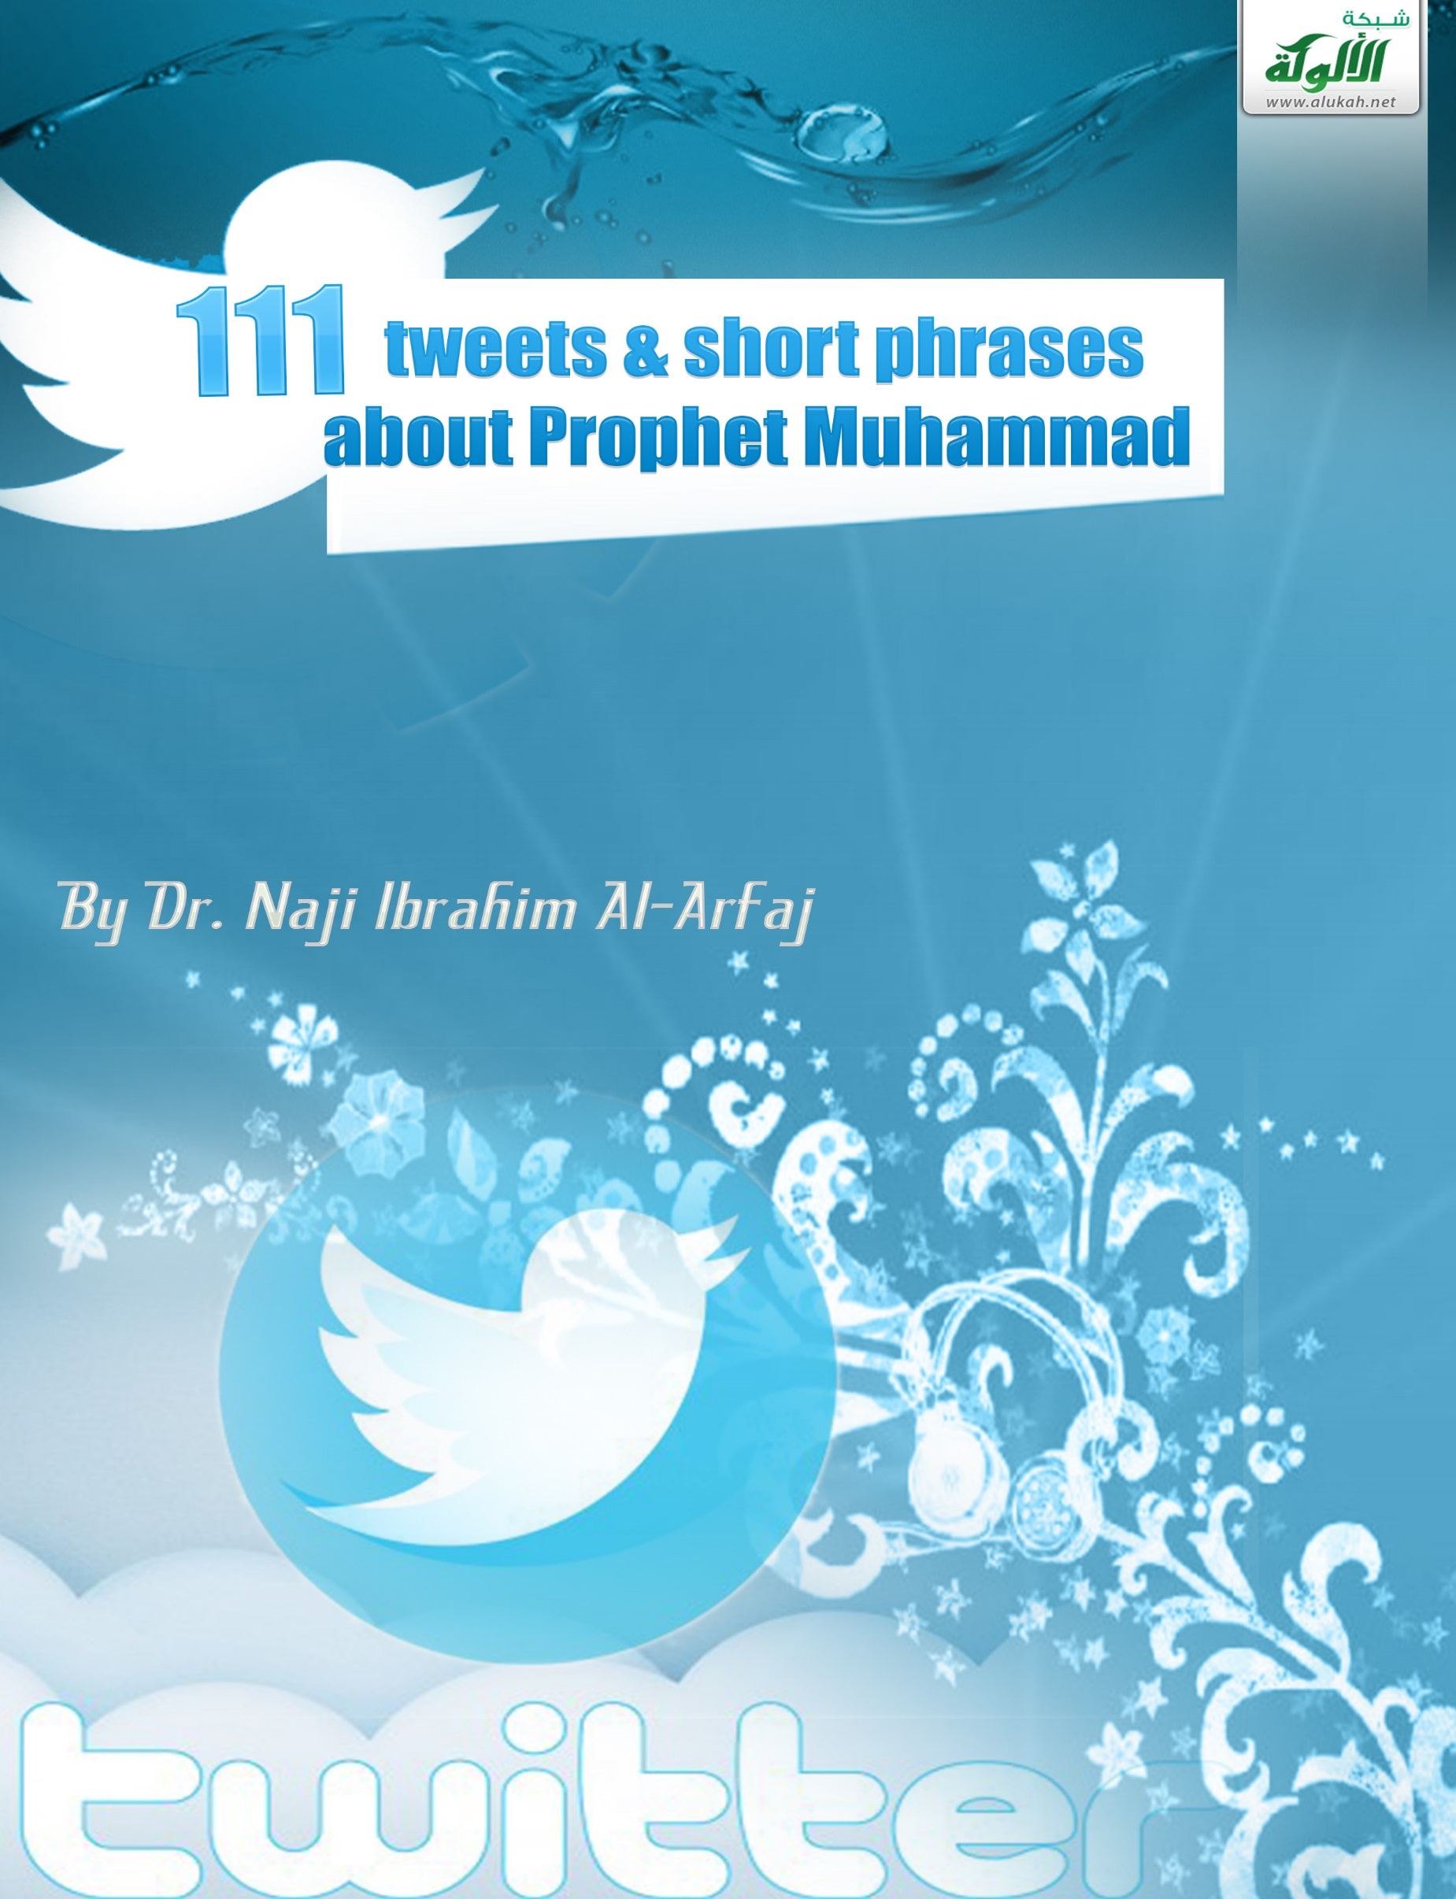

111 tweets & short phrases
about Prophet Muhammad

By Dr. Naji Ibrahim Al-Arfaj

111 tweets & short phrases about Prophet Muhammad
By Dr. Naji Ibrahim Al-Arfaj
www.etawasol.org

@najialarfaj
Muhammad (may Allah's blessings and peace be upon him) the son of Abdullah, was born in Makkah around the year 570 C.E.
#KnowHim!
@najialarfaj
Muhammad was known by his people as Al-Amin (the trustworthy one).
#KnowHim!
@najialarfaj
When Muhammad reached the age of 40, the angel Gabriel came to him with revelation.
#KnowHim!
@najialarfaj
Muhammad is the last Prophet of Allah (God); the Messenger who has been sent to all mankind.
#KnowHim!
@najialarfaj
Allah the One True God revealed to Prophet Muhammad the Glorious Qur’an.
#KnowHim!
@najialarfaj
Prophet Muhammad ordered us to respect and care for our parents, especially our mothers.
#KnowHim!
@najialarfaj
Muhammad encouraged us to help, feed, and support the weak, the poor, the needy, and the disabled.
#KnowHim!
@najialarfaj
Muhammad commanded us to be kind to and care for our families, spouses, and children.
#KnowHim!
@najialarfaj
Muhammad said: "Actions are according to intentions”.
#KnowHim!
@najialarfaj
Prophet Muhammad invited people to the Oneness (TAWHEED) of the true God, to believe in Allah and worship Him ALONE.
#KnowHim!
@najialarfaj
Muhammad said: “It was only their excessive questioning and disagreeing with their Prophets that destroyed those who were before you.”
Prophet Muhammad instructed us to greet others (spread peace ‘Salam’).
#KnowHim!
@najialarfaj
He teaches us that all humans are equal regardless of race, color, or nationality.
#ProphetMuhammad
@najialarfaj
Muhammad commands Muslims to praise and glorify Allah & to seek God’s mercy and forgiveness.
#KnowHim!
@najialarfaj
Muhammad ordered Muslims to believe in all Allah’s messengers & prophets like Adam, Noah, Abraham, Moses, and Jesus!
#KnowHim!
@najialarfaj
Muhammad told us to have good intentions, positive attitudes, and kind feelings towards others.
#KnowHim!
@najialarfaj
With an open mind and sincere heart, honestly try to find out the truth about Prophet Muhammad!
#KnowHim!
@najialarfaj
If your mind is captive to prejudice and prejudgment, you will never discover the truth about Prophet Muhammad.
#KnowHim!
@najialarfaj
Prophet Muhammad and Allah’s prophets have confirmed the existence of God, His oneness, and His worship alone.
#KnowHim!
@najialarfaj
Muslims are believers in and followers of Muhammad, Noah, Abraham, Moses, Jesus and the prophets of Allah, the One True God.
#KnowHim!
@najialarfaj
Muhammad was the last Prophet, “the Seal of the Prophets.”
#KnowHim!
@najialarfaj
Prophet Muhammad was the final prophet and was sent to confirm the truth that was revealed before him.
#KnowHim!
@najialarfaj
Prophet Muhammad said, “If a man believes in Jesus and then believes in me [Muhammad], he will get a double reward.”
#KnowHim!
@najialarfaj
Prophet Muhammad stated, “I am the nearest of all the people to Jesus, the son of Mary; for there was no prophet between me and him [Jesus].”
#KnowHim!
@najialarfaj
Muhammad has been seen by fair people, throughout history, as a special and great personality in his unique character and morals.
#KnowHim!
@najialarfaj
The details of the private life of Muhammad and his sayings and actions in public have been accurately preserved till today.
#KnowHim!
@najialarfaj
The Glorious Qur’an does testify that “Muhammad is the Messenger of Allah, and Seal of the prophets.” (33:40)
#KnowHim!
@najialarfaj
Muhammad was a messenger, religious teacher, social reformer, leader, statesman, faithful friend, loyal companion, devoted husband, and loving father.
#KnowHim!
@najialarfaj
Prophet Muhammad was merciful, honest, sincere, kind, and humble.
#KnowHim!
@najialarfaj
Ramakrishna Rao, an Indian Professor of Philosophy, in his booklet, Muhammad: The Prophet of Islam, calls Muhammad the "perfect model for human life."
Professor Rao clarifies: “The personality of Muhammad, it is most difficult to get into the whole truth of it. Only a glimpse of it I can catch. What a dramatic succession of picturesque scenes! There is Muhammad, the Prophet. There is Muhammad, the Warrior; Muhammad, the Businessman; Muhammad, the Statesman; Muhammad, the Orator; Muhammad, the Reformer; Muhammad, the Refuge of Orphans; Muhammad, the Protector of Slaves; Muhammad, the Emancipator of Women; Muhammad, the Judge; Muhammad, the Saint. All in all, these magnificent roles, in all these departments of human activities, he is alike a hero."
#KnowHim!
@najialarfaj
Muhammad changed his people in Arabia from tribal quarrels and wars to solidarity and unity.
#KnowHim!
@najialarfaj
Prophet Muhammad transformed Arabs from drunkenness and moral bankruptcy to the highest standards of moral excellence, seriousness, and piety.
#KnowHim!
@najialarfaj
Human history has never known a complete transformation of a society, minds, and hearts like what has been achieved by Muhammad.
#KnowHim!
@najialarfaj
In his book, Muhammad in the Bible, Dr. Abdul-Ahad Dawud (formerly the Reverend David Benjamin) stated several prophecies about Prophet Muhammad.
The Bible (Deut. 18:18) says, “I will raise them up a Prophet from among their brethren, like unto thee; and I will put my words in his mouth.” Who was that Prophet?
In reference to the prophecy about Muhammad in the Bible (Deut. 18:18), Dr. Dawud concludes: “If these words do not apply to Muhammad, they still remain unfulfilled”.
Prophet Muhammad urged us to smile sincerely and be kind to others.
Muhammad commands us to have good conduct and behave with respect towards others.
Muhammad instructed us to forgive and love for others what we love for ourselves.
Muslim scholars assert that the biblical prophecies about the coming of a prophet apply to none other than Muhammad. Moses and Muhammad are alike in many ways. They both have the same first letter of their names. They are alike in their natural births, marriages, missions, and natural deaths. Both were prophets, rulers, leaders, and statesmen. Both brought a "fiery law." On the other hand, Jesus is unlike Moses in several matters. His birth, mission, and end are unlike those of Moses. Jesus did not get married; nor did he rule his people or fight in wars like Moses.
he teaches us to be gentle to humans, animals, birds, and our environment.
#Muhammad
@najialarfaj
He tells us to respect and care for our parents and the elderly, and to be good to our families, spouses, and children.
#Muhammad
@najialarfaj
He encouraged us to help, feed, and support the weak, the poor, the needy, and the disabled.
#Muhammad
@najialarfaj
He urged us to think, ponder, reason, and base our judgments on proof.
#Muhammad
@najialarfaj
He told us that all humans are equal regardless of their race, color, or nationality.
#Muhammad
@najialarfaj
It instructed us not to hurt, hate, transgress against, put down, or despise others.
#Muhammad
@najialarfaj
He taught us why we are here, who brought us, where we are heading, and what our last destination is.
#Muhammad
@najialarfaj
He instructed us to live in peace and good relationship with God, self, and others.
#Muhammad
@najialarfaj
In the New Testament of the Bible, Jesus prophesied the coming of another Prophet. (John 14:16).
Jesus said, “When he, the Spirit of truth, is come, he will guide you into all truth: for he shall not speak of himself; but whatsoever he shall hear, [that] shall he speak: and he will show you things to come. He shall glorify me..." (John 16:7-14)
He invited people to worship none but the One True God (Allah), the Creator.
#Muhammad
@najialarfaj
Muhammad was worshipping and praying to Allah, the One True God. Was Jesus doing that or not?!
Referring to John the Baptist, the Bible (John 1:19-21) asks, “…Who are you? And he (John) confessed, I am not the Christ. And then they asked him, What then? Are you Elijah? And he said, I am not. Are you that Prophet? And he answered, No”.
So, who is that Prophet?
In his book, The 100: A Ranking Of The Most Influential Persons In History, Michael H. Hart stated: “My choice of Muhammad to lead the list of the world’s most influential persons may surprise some readers and may be questioned by others, but he was the only man in history who was supremely successful on both the religious and secular levels.”
Hart concluded that, “it is this unparalleled combination of secular and religious influence which I feel entitles Muhammad to be considered the most influential single figure in human history.”
Prophet Muhammad said, “I have been sent to perfect the noble traits of character.”
Prophet Muhammad told us to be gentle to humans, animals, birds, and our environment.
Professor John Esposito pointed out in his book, Islam: The Straight Path that: “Muhammad was among those great religious figures, prophets and founders of religions, whose remarkable character and personality inspired uncommon confidence and commitment. His phenomenal success in attracting followers and creating a community-state that dominated Arabia could be attributed not only to the fact that he was a shrewd military strategist but also to the fact that he was an unusual man… Muhammad’s followers found him righteous, trustworthy, pious, honest and compassionate.”
Professor Esposito stressed this fact: “Islam brought a reformation; it was the call once again to total submission (Islam) to Allah and the implementation of His will as revealed in its complete form one final time to Muhammad, the last, or ‘seal,’ of the prophets. Thus, for Muhammad, Islam was not a new faith but the restoration of the true faith...”
When Prophet Muhammad entered Makkah and liberated it from idolatry, he forgave his enemies, announcing: “You may go. You are free.”
Prophet Muhammad said: "The Compassionate One [Allah] has mercy on those who are merciful”.
Prophet Muhammad said: None of you is a true believer until he wishes for his brother what he wishes for himself.
Prophet Muhammad said: “He who eats his fill while his neighbour goes to bed without food is not a believer.
Prophet Muhammad said: “The powerful is not he who knocks the other down, indeed the powerful is he who controls himself in a fit of anger.”
Prophet Muhammad said: “God does not judge you according to your bodies and appearances but he scans your hearts and looks into your deeds.”
Prophet Muhammad said: “The best of you [is he] who is best to his family, and I am the best among you to my family.”
Prophet Muhammad said: “The best of you are those who are best to their women.”
Prophet Muhammad said: “The best of Islam is to behave with gentleness and tolerance.”
Prophet Muhammad said: “The best people are those most beneficial to [other] people.”
Prophet Muhammad told us about things to come through many prophecies and miracles given to him by Allah (God) who sent him.
Allah, the true God sent His Last Prophet Muhammad to all mankind (Jews, Christians, Muslims, Hindus, Buddhists, Atheists, Agnostics, etc.)
Prophet Muhammad carried the message of ‘Tawheed’ (Oneness & Submission) to the One True God (Allah).
Prophet Muhammad told us that the gateway to a happy, content, and eternal life is through believing in Allah (God) and worshipping Him alone.
Muslims believe in all Allah’s true prophets and messengers (including Adam, Noah, Abraham, Moses, Jesus, and Muhammad).
Prophet Muhammad said: “A good word is charity.”
Prophet Muhammad said: “Your smile in the face of your brother is charity.”
Prophet Muhammad said: “The best of you are the best in character.”
Prophet Muhammad said: “Removing a harmful thing from the path (road) is charity.”
Prophet Muhammad said:
“The best [aspect] of faith is patience and tolerance.”
A man asked Muhammad, the Messenger of Allah: “Which aspect of Islam is best?” He replied, “Feed and greet both those you know and those you do not know.”
Prophet Muhammad said:
"The Compassionate One [God] has mercy on those who are merciful. If you show mercy to those who are on the earth, He Who is in heaven will show mercy to you."
Prophet Muhammad said:
“None of you truly believes until he wishes for his brother what he wishes for himself.”
Prophet Muhammad said:
“He who eats his fill while his neighbor goes to bed without food is not a believer.”
Prophet Muhammad said:
“He who eats his fill while his neighbor goes to bed without food is not a believer.”
Prophet Muhammad said:
“The powerful is not he who knocks the other down, indeed the powerful is he who controls himself in a fit of anger.”
Prophet Muhammad said:
“God does not judge you according to your bodies and appearances but he scans your hearts and looks into your deeds.”
Prophet Muhammad said:
“The best of you [is he] who is best to his family, and I am the best among you to my family.”
Prophet Muhammad said:
“The best of you are those who are best to their women.”
Prophet Muhammad said:
“The best of Islam is to behave with gentleness and tolerance.”
Prophet Muhammad said:
“The best people are those most beneficial to [other] people.”
The Messenger of Allah, peace and blessings be upon him, said:
O people, Allah is pure and He accepts only what is pure. Verily, Allah has commanded the believers as He commanded His Messengers. Allah said: O Messengers, eat from good things and act righteously, for I know what you do (23:51). And Allah said: O you who believe, eat from good things We have provided for you. (2:172)
Prophet Muhammad’s dealings and actions with others reflected his special and unique personality in his morals, mercy, honesty, sincerity, kindness, truthfulness, humbleness, generosity, forgiveness, patience, and tolerance, as well as many other great qualities.
Practicing what he said and taught, Prophet Muhammad forgave his opponents who rejected him and disbelieved in his message.
When his enemies were persecuting and maltreating Muhammad, trying to kill him, torturing and killing his followers and beloved ones, fighting him and his companions and driving them out of their homes, properties, and land…
What was the reaction of Muhammad towards his enemies when he entered Makkah and liberated it from idolatry and paganism? He forgave them!
When Muhammad entered Makkah, he asked those who rejected him, “What do you think I am going to do with you?” They answered, “You are a generous brother and the son of an honorable brother of ours.” Then, the kind, tolerant, generous and merciful Prophet forgave them, announcing: “No harm will come to you. You may go. You are free.”
Muhammad, Jesus, and Moses used to say ‘Insha Allah’ (if God wills), and using the greeting: ‘Asalamu Alaikum’ ( Peace be upon you)!
Muslims follow the commandments that Muhammad, Jesus, and Moses taught and did, like believing in one God, praying, fasting, and giving charity.
Allah sent Muhammad as a mercy to all mankind.
Muhammad taught us the six articles of Islam: Belief in Allah (the one true God), His angels, His revelations, His Messengers, the Last Day, and destiny.
Prophet Muhammad explained to us the five pillars of Islam: Shahadah (the testimony), Salat (prayer), Zakat (charity), Sawm (fasting), and Hajj (pilgrimage).
Prophet Muhammad said: “Leave what makes you doubtful for what does not make you doubtful. Verily, truth brings peace of mind and falsehood sows doubt.”
The Messenger of Allah, Muhammad, peace and blessings be upon him, said:
“Verily, part of the perfection of one’s Islam is leaving what is none of his business.”
Prophet Muhammad said: “None of you truly believes until he loves for his brother or his neighbor what he loves for himself.”
The Messenger of Allah, Muhammad said: “Whoever believes in Allah and the Last Day, let him speak goodness or remain silent. And whoever believes in Allah and the Last Day, let him honor his neighbor. And whoever believes in Allah and the Last Day, let him honor his guest.”
The Quran told us if we truly love Allah, we must follow Muhammad then Allah will love us. (3:31)
The Quran states: “And We have not sent you, [O Muhammad], except as a mercy to the worlds.” (21:107)
Prophet Muhammad said: “Do not get angry.”
The Messenger of Allah, Muhammad, stated: “Say: I have faith in Allah. Then remain steadfast to it.”
Those who seek the truth sincerely must believe in Allah and His Last Prophet Muhammad and utter this testimony: I testify that there is no god but Allah, and I testify that Muhammad is the messenger of Allah.”

